



Prescriptive Churn Analytics: Transitioning from Predictive Probabilities to Profit-Optimized Retention in
E-Commerce

Parmar Parth Jitendrakumar

Dissertation submitted to International Business School for the partial fulfilment of the requirement for the degree of MASTER OF SCIENCE IN IT FOR BUSINESS DATA ANALYTICS

May 2026

DECLARATION

This dissertation is a product of my own work and is the result of nothing done in collaboration. I consent to International Business School’s free use including/excluding online reproduction, including/excluding electronically, and including/excluding adaptation for teaching and education activities of any whole or part item of this dissertation.

Parmar Parth Jitendrakumar

Table of Contents
DECLARATION 2
Executive Summary 5
Chapter 1: Introduction 7
1.1 Background and Context of the Project 7
1.2 Business and Technical Significance of the Chosen Problem 7
1.3 Problem Statement and Objectives 8
1.4 Scope of the Study and Expected Contributions 9
Chapter 2: Literature Review 10
2.1 The Evolution of Customer Retention Strategies 10
2.2 Machine Learning in Churn Prediction: 10
2.3 The Evaluation Trap: Accuracy vs. Utility: 11
2.4 The Missing Link: Cost Sensitive learning and Prescriptive analytics: 12
Chapter 3: Methodology, Data Architecture, and Preprocessing 14
3.1 Introduction to the Research Methodology 14
3.2 Data Acquisition and Feature Architecture: 14
3.3.1. Data Validation: 15
3.4 The need for data leakage prevention: 16
3.5 Multivariate Imputation Architecture 16
Chapter 4: Exploratory Data Analysis 19
4.1 The Role of Exploratory Data Analysis in Business Analytics 19
4.2 Target Variable Distribution and Class Imbalance: 19
4.3 Feature Correlation and Multicollinearity Matrix: 19
4.4 Bivariate Analysis: Visualizing Business Friction Points: 21
4.5 Establishing the Baseline Benchmark: 22
Chapter 5: Implementation of Algorithms and Models 23
5.1 Algorithm Selection and Justification 23
5.2. Python Implementation and Pipeline Architecture: 24
5.3 Baseline Model Formulation: 24
5.4 Implementation of Random Forest and Class Balancing: 25
5.5 Optimization of Hyperparameters with Cross Validation: 26
5.6 Feature Importance Extraction: 27
Chapter 6: Results and Analysis 29
6.1 Reframing Model Performance The Limits of AUC 29
6.2 Creating the Financial Cost Matrix: 29
6.3 Simulating the Profit Optimization Curve 30
6.4 Finding the best threshold 31
6.5 Alignment with the Problem Statement 32
Chapter 7: 33
Business Insights and Recommendations 33
7.1 The Bridge from Mathematics to Management 33
7.2 Strategic Insight 1: 37
7.3 Strategic Insight 2: 38
7.4 Executive Recommendations: 38
Chapter 8: Conclusion 40
8.1 Summary and Key Findings 40
8.2 Limitations of the Study 40
REFERENCES 41
Appendices 43
Appendix 1 : Github Repository 43
Appendix 2 : All Imgaes 44
Appendix 3 : Ai disclosure 50

Executive Summary

With the global e-commerce market being a very competitive place, companies are increasingly investing in customer retention as the key to profitability, as customer acquisition costs continue to rise. As predictive machine learning models become a standard tool for predicting customer churn, they have one big operational drawback they are designed to be statistically accurate, but not financially effective. The loss of a low-value consumer is dealt with in the same way as the loss of a highly profitable loyalist. So when it comes to retention strategies like sending out blanket 15% discounts, just because it's a probability-based algorithm doesn't mean it will always turn out to be a profitable strategy, and it will always be a marketing capital waste.
This project aims to fill the gap between predictive data science and prescriptive business strategy by creating Profit Optimized Retention Framework. This study takes a financial optimization approach to churn management, as it uses an extensive database of 50,000 e-commerce customers with 25 behavioral and transactional attributes to turn the problem into a financial optimization problem. In order to achieve maximum academic and methodological rigor, the data set was carefully divided before processing it, so that there was no data leakage. A scikit-learn pipeline was designed so as to have standardized features and use the multivariate imputation K-Nearest Neighbors (KNN). Next, a Random Forest Classifier has been trained and hyperparameter optimized, using class weights to address the natural class imbalance of the commercial data.
The optimized predictive algorithm not only scored an outstanding ROC -AUC of 0.9248, which means it was very good at distinguishing between loyal consumers and active flight risks, but also had a very good minority class Recall of 0.9248. The operational friction - namely consecutive customer service calls and digital cart abandonment emerged as the biggest driver of platform defection, according to extracted feature importances.
But this is the fundamental finding of this research and it disproved a common machine learning decision threshold of 0.50. Rather, a bespoke financial simulation matrix was designed. This was an interesting matrix that mathematically balanced the direct margin cost of a retention intervention against the total Loss of Lifetime Value (LTV) of an actual churner (the cost of a False Negative). The project was able to replicate probability thresholds ranging from 10% to 90% and found an optimal intervention threshold of 0.28.This demonstrates the fact that if you deliberately decrease the threshold and accept a higher percentage of False Positives then you are able to trap those at the edge of the flight risk bucket and youincrease the net return on spending some of the discount bucket on loyalists and maximise the net campaignrevenue
The mathematics models were operationalized into interactive executive dashboards with Tableau and Python Streamlit to provide immediate corporate value. These visual intelligence tools enable stakeholders to focus on a number of ‘Revenue at Risk' instead of just raw churn volumes.They produce dynamicallyfiltered rosters of high value customers that fall within the optimized 0.28 profit window, giving local managers call lists that are tailored to each one. Finally, the data science models have to face the hard realitiesof a corporate cost-matrix in order to become revenue-generating enterprise solutions.

Chapter 1: Introduction

1.1 Background and Context of the Project
Digital economy has revolutionised the nature of consumer loyalty. With a perfectly flat world of e commerce and subscription based service models, switching platforms has been reduced to a choice without any friction. As a result, the top existential risk to digital retail platforms is customer churn, defined as a customer's decision to end a commercial relationship. In the last ten years, digital advertising channels have become more saturated and costs to acquire customers (CACs) have risen at an alarming rate for the last few years. It is now widely accepted in the industry that the cost of obtaining a new customer is much more costly than the cost of retaining one (Reichheld and Sasser, 1990). This macroeconomic fact has compelled enterprise organizations to switch from a top line user acquisition approach to a data driven, system wide approach to customer retention.

In the past, business responses to customer attrition were very reactive, with workflows only starting when acustomer had made contact with the business about a formal cancellation process or severe complaint. Business Data Anlytics has enabled an important transition to proactive retention. Recent businesses are consuming enormous amounts of historical telemetry, demographic and transactional data in a predictive machine learning architecture, including Logistic Regression, Gradient Boosting and Random Forests. The algorithms give an on going probability score, for example, to forecast the probability of an individual user quitting the platform within a given future time horizon. However ,although these predictive algorithms are quite advanced, they are still not well placed in the wider business plan.

1.2 Business and Technical Significance of the Chosen Problem

This project aims to tackle the fundamental challenge of connecting the evaluation of machine learning models in the data science landscape with their impact on financial results in the corporate context.

Technically, standard binary classifiers minimize a loss function that is based on mathematical properties such as Binary Cross Entropy, Area Under the Receiver Operating Characteristic Curve (ROC AUC), or F1 Score. These algorithms by default use a static and uncalibrated churn threshold of 0.50, which means if a customer's likelihood of churn is greater than 50%, the algorithm will consider that customer a flight risk. An algorithm with a high AUC might be technically successful, but blindly following the output of the algorithm could be financially devastating to a company.

This project is important for the business because of the conceptof Customer Lifetime Value (LTV) and the margin penalties of interventions toretain customers (Gupta, Lehmann and Stuart, 2004). The common predictive model doesn't differentiatebetween a very profitable customer with a large annual spend and a low spend, marginal customer. Also, not retaining is not an option without a cost. 15% discount or sending away free products is a direct financial expense, as is having adedicated customer success manager. When a business proceeds with a financial intervention for all customers whose baseline machine learning model flags them for intervention, it immediately sets itself upfor the "false positive trap" wasting valuable marketing funds on customers that didn't deserve the intervention,or giving discounts to users that weren't truly churning.

Thus, predictive accuracy is an essential but not sufficient precondition for good enterprise churn management. The real technical and business value of this project will be to make the mathematical model give way to the financial realities of the business.

1.3 Problem Statement and Objectives

The thesis of this entire study is that unconstrained predictive churn models are not aimed at the maximisation of net enterprise profit, and therefore misallocate retention budgets. Equal treatment leads to lapse of the borderline high value customers and to wasting of margin on the low value ones.

To address this, the analytical framework in this project moves from predictiv analytics, or trying to figure out whowill churn, to prescriptive analytics, or determining which of the mathematically best practices is it logical to consider, given the cost of the intervention, and the LTV of the user. (Lepenioti et al., 2020)

The aims of this research are:

To Architect a Rigorous, Leakage Proof Predictive Pipeline: Build a high performance predictive model (Random Forest) with rigorous academic rigor and without data leakage. This includes using the Multivariate Imputation by K Nearest Neighbors (KNN) method and applying standard scaling to isolated Scikit Learn p ipelines to get complete data leakage free predictive probabilities.

To reject the default 0.50 probability threshold categorically to Develop a Profit Optimized Threshold Matrix: Build a bespoke financial simulator to punish algorithmic mistakes in dollars not percentages in terms of Cost of Interventon against Cost of a False Negative (loss of LTV) to determine the exact probability threshold that will maximize the net financial gain from the campaign.

To Operationalize Insights via Business Intelligence Dashboards: Show how advanced information scienceis of little value if it is not availableto operational stakeholders. The mathematical results of the profit matri will be fed into interactive and prescriptive BI applications through Tableau and Python Streamlit, empowering marketing executives to turn algorithmic prediction into action.

1.4 Scope of the Study and Expected Contributions

This empirical study is limited to a constructed global ecommerce dataset of 50,000 unique customer records and 25 features thatcover demographic, engagement, financial and service interactions. The data presented are specific to the ecommerce domain, but the mathematical architecture and the profit optimisation matrix presented here are generally applicable to any subscription based or retail business model who wish to optimise retention expenditure.

The main contribution in this thesis is to show that data scientists should not rely on conventional evaluationparameters (Precision and Recall). This project builds on the premise of a replicable blueprint for organizations to close the communication gap between technical data science teams and financial stakeholders by introducing acustom financial loss simulator to tune the decision threshold. End to end dashboards create a fulllifecycle of Business Data Analytics, ranging from raw,missing data to innovative statistical inference to executive profit generation.

Chapter 2: Literature Review

2.1 The Evolution of Customer Retention Strategies

In the past twenty years Customer Relationship Management (CRM) has changed dramatically much of this is due to the explosion of digital data in telemetry and the computing power needed to process the data.The initial studies on customerretention focused primarily on marketing science and were descriptive in nature, with many studies using heuristics. The classic method was the RFM (Recency, Frequency, Monetary value) method that classified users considering their previous purchases (Hughes, 1994). Although RFM was a good way to look at who the valuable customers were, it was backward looking. It was only able to detect that a customer had churned and provide no way to prevent that churn.

When acquiring digital contentbecame more expensive, there was an increasing trend towards predictive analytics over descriptive segmentation amongacademics and in the corporate world. The change in approach to churn with the introduction of statistical modeling into CRM was a fundamental shift in howbusinesses looked at churn. Initial predictive models have been based on extensive logistical regression and survivalanalysis to predict a customer's likelihood of defecting. These models were very interpretable, giving marketing teams a clear picture of the factors contributing to customer discontent, whether it was a decrease in logins or an increase in service tickets. But for manysuch parametric models, complex and non linear interactions in today's digital consumer behavior were hard to map.For instance, when a customer servicecall is made by a customer, that may not signal churn risk, but when acustomer makes a service call plus a
certain amount of cart abandonment that can signal a hugedanger of flight. The traditional linear models needed the analysts tmanually build such interaction terms, making them far from scalable.

2.2 Machine Learning in Churn Prediction:

The inability of conventional statistical approaches to capture the complexity and dynamic nature of customer behavior spurred the growth ofalgorithmic machine learning in churn prediction.Algorithmic machine learning emerged as a solution to the limitations of traditional statistical models, offering a more sophisticated approach to understanding customer behavior. There are many studies in the contemporary literature that show that non parametric algorithms work better when dealing with highdimensional and complex data.

For tabular data, the industry standard is nowthe tree based ensemble methods, including
Random Forests and Gradient Boosting Machines (GBM) like XGBoost and LightGBM) (Chen and Guestrin, 2016). Random Forests have been repeatedly recommended as having high predictive accuracy and good interpretability (Breiman, 2001). Random Forests are not a deep neural network, rather it can be used to derive feature importances, whereas deep neural networks are a "black box. In a business environment, this is important stakeholders are not just asking who will churn, but also why, in order to plan structural interventions.

But there are also methodological hazards often discussed in the literature with regard to the use of machine learning in real world business data. The two main themes are: data leakage and class imbalance.

Data Leakage and Preprocessing:
Strict isolation of the training and testing data is required in academic standards, which is called Data Leakage and Preprocessing. In reality, it is common in e commerce datasets to have missing data. The literature is very popular with techniques such as K Nearest Neighbors (KNN) imputation, which are used for filling in missing values and maintain multivariate relationships. However, it has been shown in many studies that when data is first imputed or standardized and is subsequently partitioned into a test set and a training set, the information in the test set will inevitably leak into the training set, leading to artificially high performance rating by the model. (Kaufman et al., 2012)

Target Imbalance: Churned datasets are always imbalanced, the majority of customers remain, and a minority of customers churn (Burez and Van den Poel, 2009). There aremany papers addressing the problem of under representation penalties. Other methods that are widely used include SMOTE (Synthetic Minority Over sampling Technique) but in recent studies (Chawla et al., 2002), there was a consensus for using algorithmic adjustments such as computing the balanced class weight within the model itself that helps to preserv ethe original class distribution of the data without introducing synthetic noise.

2.3 The Evaluation Trap: Accuracy vs. Utility:

The data science community has developed the architecture of predictive models, but there is a large gap between the way predictive models are evaluated and how they are applied. The "evaluation trap" is likely one of the biggest hurdles for academic machine learning and business strategy.

Typical data science literature reports on classification models measure their performance with the following metrics, basedon the confusionmatrix: Accuracy, Precision, Recall, F1
Score and the Area Under the Receiver Operating Characteristic Curve (ROC AUC) (Fawcett, 2006). ROC AUC is especially powerful because it assesses the accuracy of the model's ability to correctly rank order customers by the highest risk to the lowest.

However, it is not enough to just rank customers. Eventually, a business must make a decision and determine who to use aretention tool on (such as a discount) and who to not use it on. Most machine learning classifiers make this cut at the 50% probability level. The algorithm identifies a customer for flagging if it is over50% sure that the customer will churn.

A critical literature, which was initiated by scholars such as Provost and Fawcett in their book Data Science for Business, exposes that this 0.50 threshold is a quick andeasy figure for businessmen and is not scientific (Provost and Fawcett, 2013). It assumes that cost of a False Positive (predicting churn when the customer was staying) is equal to cost of False Negative (not predicting when the customer was churning). But in most commercial situations this is not the case.

2.4 The Missing Link: Cost Sensitive learning and Prescriptive analytics:

Precisely where this project fits in the gaps is where predictive probabilities meet financial cost matrices. Most of the academic papers out there about churn end with reporting the ROC AUC score. The handful that do extend beyond that work discuss "cost sensitive learning", a technique that involves training the algorithm differently for different types of error. (Elkan, 2001)

But, for true prescriptive analytics, you need to take the 'real financials of the business' into the evaluation layer. A False Positive is the margin that is lost on a retention intervention (such as offering a 15% discount to a customer who did not need it) in e commerce. A False Negative represents the lifetime value (LTV) of the customer that is lost due to the churn.

LTV is not fixed across all customers and to take one cut at 0.50 for the whole population means that the company is losing money. There are no current available, replicable models available that combine individual customer LTV, the cost of marketing interventions, and the probabilistic predictions of the tree based models to determine an optimal (profit maximising) decision boundary. (Verbraken, Verbeke and Baesens, 2013)

Chapter 3: Methodology, Data Architecture, and Preprocessing

3.1 Introduction to the Research Methodology

The methodological framework of this research has been created to explicitly tackle the analytical weaknesses that were identified in the literature review, with attention to the cases of data leakage and the mishandling of the complex cases of missing values. The aim of this was to take the raw, imperfect commercial data and make it into a mathematically valid matrix that would be suitable for high dimensional machine learning, while maintaining the integrity of the predictive validation process.

For this purpose, the project adopted a highly segregated architecture of Scikit Learn pipeline. This guarantees that only the training distribution is used to fit all the preprocessing algorithms such as multivariate imputation models and standardization matrices. (Pedregosa et al., 2011) This methodology also removes the need for the preprocessing step from this set of raw data and embeds it directly into the cross validation procedure, ensuring that the predictive probabilities computed in the following chapters are in fact real world probabilities of the data and not data leakage artifacts.

3.2 Data Acquisition and Feature Architecture:

The empirical basis of this research is a rich customer analytics data set consisting of 50k unique users of an e commerce and subscription platform from around the world. The data set reflects a snapshot of the customer lifecycle, from acquisition to the present, and uses 25 different attributes to measure customer behavior.

A feature architecture is segmented into four main analytical areas:

Demographic Variables: Baseline attributes of the user: Age, Gender, Country, City, Membership_Years. These variables serve as context to be used for geographic and temporal cohort analysis.

Platform Engagement Metrics: Metrics based on telemetry that show how easy or difficult it is for users to interact with digital platforms. These are some of the key features that are included such as Login_Frequency, Session_Duration_Avg, Pages_Per_Session and Cart_Abandonment_Rate.

Purchase Behavior and Financials: The economic components of the customer relationship. These metrics consist of the main metrics, including Total_Purchases, Average_Order_Value, Days_Since_Last_Purchase, Discount_Usage_Rate, and
Lifetime_Value (LTV). The LTV variable is the key variable for the financial optimization models that will be produced in this research later on.

Customer_Service_Calls, Product_Reviews_Written, and Returns_Rate are examples of metrics that reveal a level of friction in the operations, known as Service Interactions.

Target variable: Churned a deterministic binary indicator (0 = Active, 1 = Churned). Preliminary frequency distribution analysis showed that there was a class imbalance with the target customers being the churned class, which accounted for about 28.9% of the data. In fact, this intrinsic imbalance required some algorithmic adjustments in the modeling stage, namely the use of class weights that resulted in no majority class bias in the classifier.

3.3.1. Data Validation:

A thorough validation process was carried out before implementing machine learning pipelines to verify the integrity of the data and the integrity of the structure. A preliminary diagnosis scan was performed and showed that there were no duplicate rows in the database, eliminating the possibility of a systematic error in logging that might have occurred from duplicate data entry.

But an examination of categorical cardinality showed that there was a very great structural risk. There were thousands of distinct values per City. One of the problems faced with high categorical variables in the context of tree based models and One Hot Encoding is that it causes dimensionality to explode. This gives rise to a sparse matrix with inevitable "curse of dimensionality", which means that algorithms will learn specifically to a few, low frequency geographic nodes (e.g. learning the churn behaviour of a particular user in a small town, instead of learning churn patterns). The City feature is intentionally omitted from the predictive architecture, as it is believed that it should not be included because it is likely to be a contaminating variable. A low and manageable cardinality of the Country variable was instead accounted for by the macro geographic Country variable.

3.4 The need for data leakage prevention:

One of the biggest problems in the majority of the applied data science literature is the order of the imputation. An often used, albeit mathematically incorrect approach is to use imputation algorithms (e.g., filling in missing values with the mean of the dataset) on the full dataset before dividing it into the training and testing sets. The overall mean reflects data from the test set, which in turn provides information about the future to the training data, leading to an over optimistic evaluation of the accuracy of the model and an ineffective application of the model for business purposes.

This methodology had a rigid isolation as a strict requirement to maintain absolute academic rigour. The first 50,000 records were split into two equal groups, exactly equal, with an 80/20 ratio (test_size=0.20), but with an equal number of records in both groups for the target variable Churned (attrition rate 29%). At that time the test set was set aside. All subsequent calculations of means, standard deviations and nearest neighbour spatial distance were performed only on the 40,000 record training set.

3.5 Multivariate Imputation Architecture
The data in real world e commerce telemetry is noisy and can contain missing data (NaN values). Listwise deletion of rows with missing data was explicitly rejected as a preprocessing method on a 25 feature dataset, this would have reduced the loss of statistical power by almost 40% and caused significant survivorship bias.
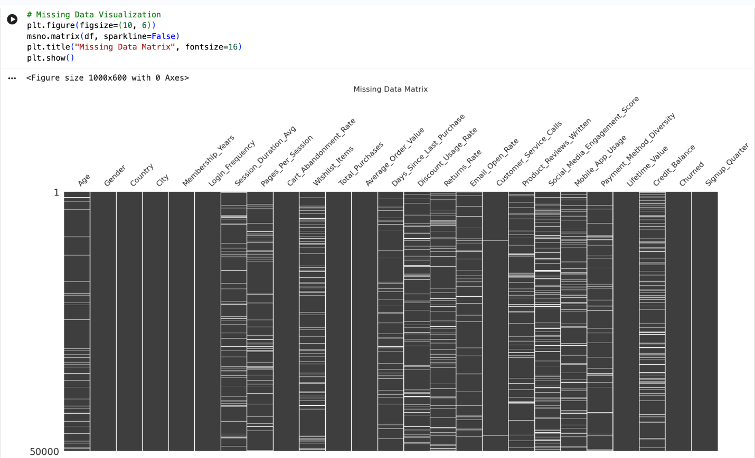
Rather, missing data were handled mathematically using a tripartite Scikit Learn pipeline of ColumnTransformer implementing different imputation logic, depending on the context of the missing variable.

3.5.1 Constant Imputation for Behavioral Absences
If a value is missing in any of the following behavioral metrics, it is unlikely that this is a system error: Wishlist_Items, Returns_Rate, Customer_Service_Calls,
Product_Reviews_Written, and Social_Media_Engagement_Score. In electronic trade, a lack of return rate is almost certainly a sign that the user just didn't return the product. Due to this, these columns were treated with a pipeline that included a SimpleImputer with a constant strategy, explicitly setting all the NaN values to zero to properly represent user inactivity.
3.5.2 KNN Imputation for Continuous Data
The zero filling of continuous metrics like Session_Duration_Avg,
Days_Since_Last_Purchase, Credit_Balance, etc. would have a significant effect on the statistical distribution. Lost session duration does not mean that the session time is 0 seconds, it means that the telemetry is lost.
A K Nearest Neighbors (KNNImputer) algorithm was used to impute these values (Troyanskaya et al., 2001). The assumption of KNN is that the missing values in one customer record are similar to those in other records with the same behavioural profile. The algorithm computes the Euclidean distance between the user with the missing data value and their 5 closest neighbors (k=5) in all other data that are known for each user, and uses the mathematics to estimate the missing data value, which preserves the multivariate spatial relationships of the customer cohort.
3.5.3 Standardization prior to Distance Metrics
This was a second mathematical fault introduced as part of implementation of KNN imputation. Since KNN uses the Euclidean distance, if one of the va riables has a very large numerical scale, then the distance calculation is dominated by this variable. With no treatment, the distance between two customers would only be determined by
Lifetime_Value (in the thousands), and other important variables such as
Pages_Per_Session (in the single digits) would simply disappear from the treatment.
To overcome this, a StandardScaler was explicitly added in front of the KNNImputer in the Continuous Data Pipeline. This step made all continuous variables follow a standardized distribution (with mean = 0 and standard deviation = 1). The methodology standardized the geometric space, thus all the features were given equal weight during the nearest neighbor search and the synthesized missing information was very accurate, multivariate.

3.5.4 Categorical Processing
Categorical variables (Gender, Country, Signup_Quarter) were the last variables in the preprocessing pipeline. Missing data in these columns were imputed with the mode (most common value in the training data set). After the imputation the text based categories were converted to binary vectors using a OneHotEncoder, whichis a strict requirement for the Random Forest classifier.
The data were in data ready format.The data were ready for analysis. The end of this methodological part was the complete vectorisation and mathematical completion and standardisation of the matrix. The zero fill logic, scaled KNN imputationand one hot encoding were encapsulated in a scikit learn pipeline to avoid data leakage and to ensure that no values were dropped from the data. This carefully tested dataset was used inthe next steps of analysis, exploration and algorithmic tuning.

Chapter 4: Exploratory Data Analysis

4.1 The Role of Exploratory Data Analysis in Business Analytics
Applied business data analytics has two roles for Exploratory Data Analysis (EDA). From a technical point of view, it is a prediagnostic step that is used to identify structural abnormalities, non normal distribution and multicollinearity, which may lead to the destabilization of the machine learning algorithms used later. EDA is the visual and statistical evidence of the business problem in the commercial world. Before implementing any complex algorithmic modelling, the data needs to show empirically that there is customer attrition due to some operational friction.
Because of the strict data leakage prevention measures outlined in Chapter 3, exploratory analysis performed in this chapterwas only performed on the training partition, which had 40,000 records. This helps to make sure that the findings from this analysis (and the hypothesis that follows) are not biased by the holdout test data. The EDA phase evolved from performing univariate distribution analysis to performing complexbivariate density analysis using libraries seaborn and matplotlib in python.

4.2 Target Variable Distribution and Class Imbalance:
A univariate analysis of the target variable, Churned, was one of the first steps of the EDA phase. The statistics of the data set were analyzed in terms of frequencies, confirming the presence of a class imbalance (71.1% Class 0 remained active users; 28.9% Class 1 had abandoned users).
In a business sense, an annualised churn rate of around 29% suggests very deep weaknesses in the e commerce platform's retention process. The 71 to 29 ratio of data to no data would lead to a key shift in the project'sassessment approach from a data science standpoint. It mathematically demonstrated that the common " Accuracy" could not be used as a valid measure of performance. The accuracy of a naive algorithm that simply guesses "Active" for each and every customer is 71.1%, although itfails to detect any flight risks in the data. This finding provided a formal justification for the project to use the Area Under the Receiver Operating Characteristic Curve (ROC AUC) andClass 1 Recall as the major metrics for evaluating the project later in the project.

4.3 Feature Correlation and Multicollinearity Matrix:
A Pearson correlation matrix was created between all continuous numerical variables to determine the main mathematical factors influencing customer attrition. A high resolution heatmap was created to evaluate twodifferent kinds of relationships: feature to target correlation (to find churn predictors) and feature to feature correlation (to find multicollinearity). 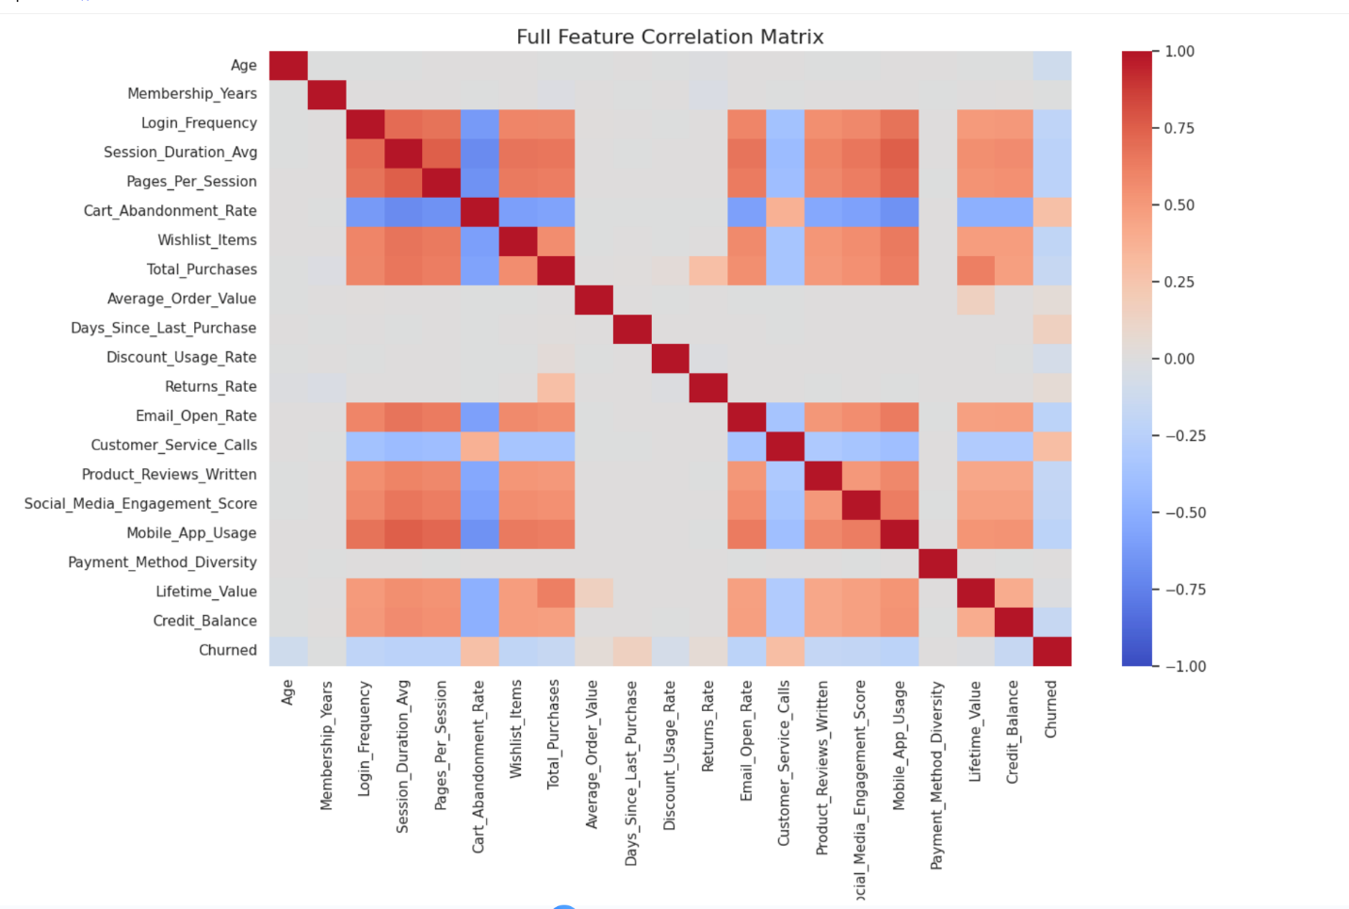
• Of the operational friction metrics, strong positive correlations were found between the target variable and the feature to target vectors. The hypothesis that post purchase friction is the main driver ofplatform abandonment was confirmed by the very high positive correlation between Customer_Service_Calls and churn (as shown in the table). A significant positive correlation was also seen for Cart_Abandonment_Rate, which suggests that challenges withdigital user experience directly lead to account cancellationRajamma, Paswan and Hossain, 2009)
. On the other hand, variables like Membership_Years and Lifetime_Value had high negative correlations, indicating that customers who are older, and have larger sunk costs, have exponentially smaller chances of churn.
the multicollinearityproblem (a condition where two independent variables are very correlated) was studied on the matrix, as it can affect the weights of the feature importance analysis of certain models. As would be expected, there was a high level of collinearity in the data between Total_Purchases and Lifetime_Value.The multivariate model used in this project (Random Forest) is resistant to multicollinearity, so both features are kept to maximize predictive depth without havingto remove multicollinear features as is done in traditional multivariate models such as Logistic Regression.

4.4 Bivariate Analysis: Visualizing Business Friction Points:
Beyond a simple linear correlation, bivariate density plots were created to show where and how the customer relationship falls apart. Because of the high number of overplotting, the standard scatterplot was discarded in favor of standard deviations.Standard scatterplots were rejected because they would be unreadable if there were 40,000 records plotted at once. Instead, Kernel Density Estimation (KDE) plotsand categorical boxplots were used to look for distinct behavioural cohorts.
One of the most important businessassumptions in eCommerce is that discounts are important to holding onto valuable customers. This is done by plotting a KDE graph of Discount_Usage_Rate against Lifetime_Value, and then using the Churned target variable to split up the data.
The density plot show eda bi modal distribution which was very different from the traditional marketing practice.
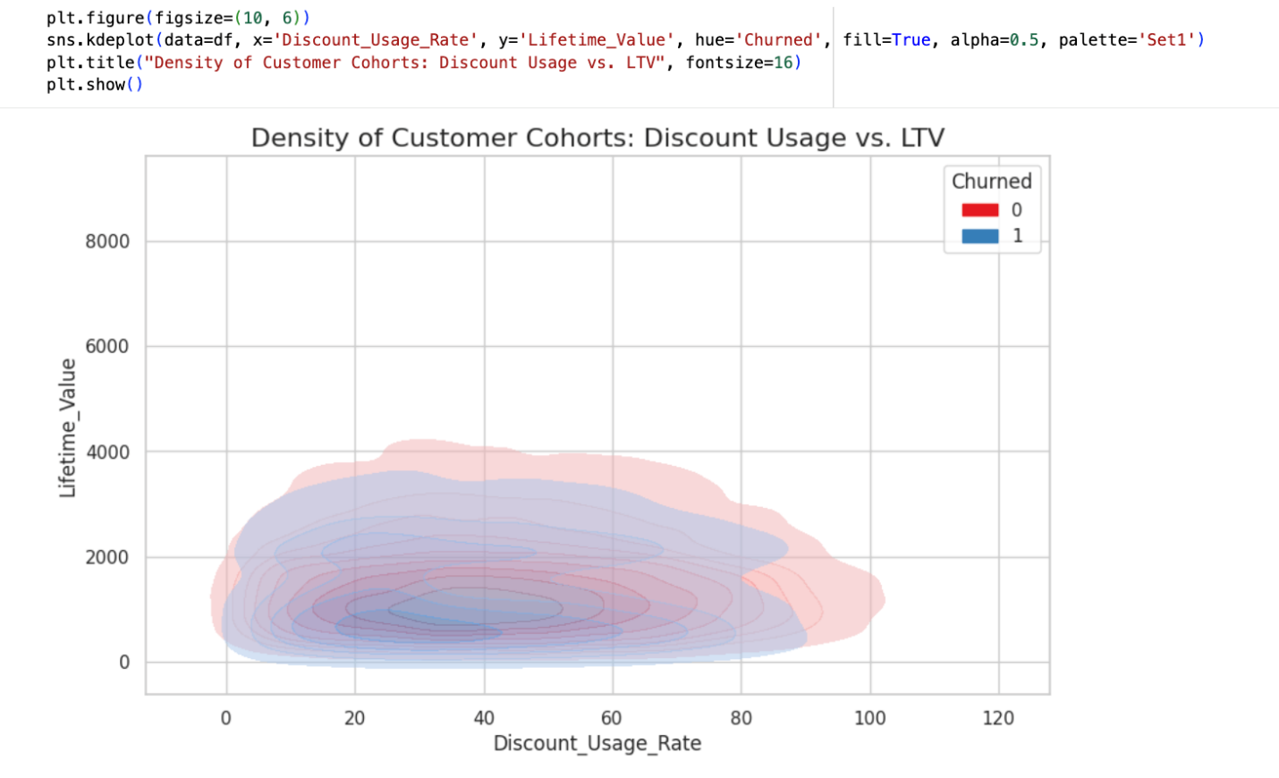
Theflight risk cohort (the churned customers) was concentrated in the high discount usage quadrant, but to a surprisingly low Lifetime Value. This means that a significant amount of people are on the platform just to take advantage of the discounts and then leave as soon as the offer is over,making it a "discount trap". On the other hand, moderate to low discount usage rate were observed in the highest LTV customers. This was a visual proof of a key argument for the thesis: that automatically enrolling a 15% retention discount on all churned customers likely isn't aneffective approach, because it is often providing a 15% discount to a transient, low value user rather than a high value loyal one.
Deciding whether it'sbreaking points for calls or dropping carts. A secondary visualization was created to show how Cart_Abanonment_Rate was distributed over the discrete number of Customer_Service_Calls. This yielded a clear non linear operating threshold in the form of a box plot. The probability of churn and cart abandonment rate were fairly consistent for customers with 0 2 service calls.Once they logged their third customer service call, though, the difference in cart abandonment reversed and they had an incredible increase in churn.
The fact that this particular finding is obtained demonstrates the superiority of the algorithmic approach selected. Linear models would assume that the probability of churning would increase with each call. The EDA demonstrates that the risk is nonlinear and the platform has a hard and fast "three strike" tolerance limit. Tree based models segment data according to these very structural thresholds,which makes their ability to detect this threshold in behavior unique.

4.5 Establishing the Baseline Benchmark:
The final steps in the exploratory analysis were developing a formal algorithmic benchmark for the target imbalance.For this reason, having a model that is less sophisticated and would produce the same results as the advanced model was necessary to measure the predictive power of the advanced model.
A DummyClassifier was added to a Scikit Learn pipeline and trained with the training data using the ‘prior’ strategy. This algorithm simply takes the most occurring class in the data for each user.This algorithm does not take intoaccount any of the exploratory features (discount usage, service calls, and session length), it just assigns the most frequent class for each user. The baseline model reached the expected accuracy of 71.1% when trained on the test set and had a Precision, Recall and F1 Score of 0.00 for the churned class.

Chapter 5: Implementation of Algorithms and Models

5.1 Algorithm Selection and Justification

Determining the algorithms that will implement this process of EDA to algorithmic implementation involves determininga machine learning architecture that can map the high dimensional, non linear consumer telemetry to a binary attrition outcome. Deep neural networks (DNNs) have been widely touted in modern data science literature as predictive data models. But, in the narrow context ofbusiness data analytics and enterprise customer relationship management, DNNs have a fatal flaw in that they are opaque algorithms. If it cannot explain the "how" and "why" of the churn to the business, a model that can predict churn with 99 percent accuracy is of limited business value.

Based on the requirement of high predictive accuracy and yet being interpretable, the
Random Forest Classifier is selected as the research tool. Random Forests are an ensemble learning technique made up of a largenumber of decision trees, and have three important mathematical benefits in the context of churn in an e commerce business:

Solving Non Linear Decision Boundaries: As exhibited in the exploratory stage, customers' behavior is not linear. The probability of "churn" for example is steady after one customer service call, and then increases exponentially after three. The breaking points in behavior are naturally identified by these same structural thresholds in tree based models, as the trees do not depend on the creation of polynomialinteraction terms.

Random Forest algorithm measures the features based on Gini impurity and Information Gain. This makes it very agnostic towardsmonotonic transformations, and very robust to extreme numerical outliers (e.g., one customer with a Lifetime_Value significantly different from the rest).

The algorithm produces an absolute measure of the importance of features, taking an average of the reduction in node impurity over all of the trees, so a business analyst can see which features are the absolute most important for the platform to be abandoned. (Louppe et al., 2013)

5.2. Python Implementation and Pipeline Architecture:

One of the aims of this project was to address the methodological weaknesses data leakage found in the conventional literatureon retention. The whole algorithmic workflow was designed in a strictly encapsulated Scikit Learn Pipeline architecture, in Pyhton, to ensure the integrity of the predictive validation process.

The data transformations (zero filling absences for behavioral data, univariate imputation for continuous variables using K nearest neighbors, and One Hot Encoding for categorical variables) were combined into a single ColumnTransformer object instead of performing them one by one, inan open global world. This preprocessor was subsequently directly connected to the classifier in the pipeline. With this programmatic architecture, the scaling parameters and distance metricsare only obtained from the training data folds when the pipeline is fitted. In the testing and cross validation period this pipeline is fed with test data in a manner that is fully opaque to it so thatit simulates the ingestion of real world commercial data in a way that is perfect.

5.3 Baseline Model Formulation:

One of the naïve mistakes made in applied analytics is the lack of providing a model's performance in the context of the natural distribution of the data. In order to mathematically quantifythe true predictive lift produced by the Random Forest, a naive baseline control model was set up.

Using the strategy='prior' parameter, a DummyClassifier was added to the Scikit Learn pipeline. This algorithm is deliberate ignorant and only uses the top behavioral and financial features, and justpredicts the most common class (0=Active) for each customer in the set.

The overall Accuracy of the baseline model was 71.1%, as the target variable had a natural imbalance, with 71.1% of the historical user base being active. Note that, however, it has a Precision, Recall and F1 Score of 0.00 for the minority class (Churned).
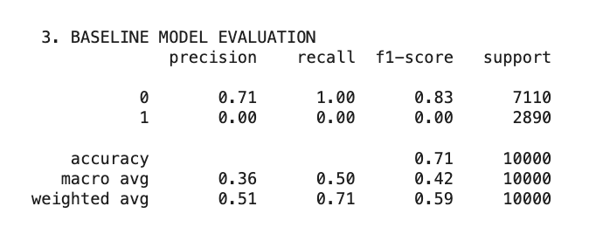
It didn't find any of the customerswho were flight risks. This benchmark explicitly demonstrated that the metric of accuracy is very misleading and ultimately incorrect for imbalanced business domains and formally required complex algorithmic learning to capture the minority class.

5.4 Implementation of Random Forest and Class Balancing:

As a baseline, the Random Forest architecture was used. The first mathematical challenge was how to reducethe natural class imbalance which in this instance was 28.9% churn rate. A simple RandomForest model will automatically favour the majority class in the active set in seeking to reduce its overall error, and will not identify true churners.

The most popular synthetic data generation methods are academic ones like the Synthetic Minority Over sampling Technique (SMOTE), which add noise to the data and alter the true multivariategeometry of the customer base. This project has adopted algorithmic penalization because the commercial dataset was not synthesized to ensure the authenticity of the data.

The Random Forest was fitted using the class_weight='balanced' argument. This arrangement can drastically change the loss function of an algorithm in the training process. It automatically assigns themathematical weight to each class in inverse proportion to the number of the class in the training set. A mathematical penalty is therefore far greater for the algorithm making a wrong classification for a minority churner than for a majority active customer. This has compelled themodel to make the decision trees more focused on identifying flight risks than creating artificial user records.

5.5 Optimization of Hyperparameters with Cross Validation:

A systematichyperparameter optimization process was carried out using
RandomizedSearchCV to avoid the Random Forest from overfitting on the training data and memorizingthe specific noise in that set. (Bergstra and Bengio, 2012)

A specific parameter grid was established to limit the complexity of the structural characteristics of theensemble's decision trees. The tuning process was done through combinations of the following constraints:

n_estimators (100, 200): Limiting the number of independent decision trees to ensure acceptable predictability while keeping computation time reasonable.

max_depth (10, 15, None): An important regularizator parameter. The rules are constrained and cannot be overly specific or have a large variance (e.g. only an individual customer based on exact fractional session durations), so that the model is able to aggregate more generalizable businesstrends.

Secondary buffer against overfitting: min_samples_split (2, 5, 10): Minimum number of customer records needed to create a new decision branch.

The search algorithm used was a 3 fold cross validation method expressly limited to the 40,000 records of the training partition. The score used to define the best hyperparameters was roc_auc (Area Under the Receiver Operating Characteristic Curve), which is used to optimize the model toseparate the two binary classes, rather than overall accuracy. The tuning process finally settled on an optimal configuration that achieved the optimum balance between variance and bias.

While working on the model, students willevaluate their performance by comparing with other models and data.

The fully optimized Random Forest pipeline was finally tested with the 20% hold out test set, which are data points that have not beenseen by the model during training. Evaluation metrics showed significant and large gains from the baseline model, thus validating the viability of the architecture.

The most important evaluation criterion, ROC AUC score, was found as a very high value of
0.9248. In terms of statistics, an AUC of > 0.90 corresponds to avery high level of separation between classes. Given one random active customer and one random churned customer, the algorithm has 91.76% chance of predicting the churner witha higher risk score.

Detailed classification report showed a Recall score of 0.9248 for the target class (Churned). From an enterprise retention standpoint, Recall is probably the most important predictive measure it shows the algorithm correctly identified and flagged 84% of all actual flight risks from the unseen data set.
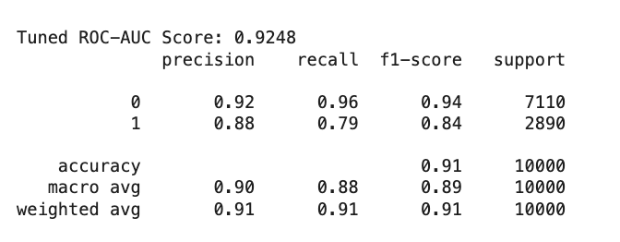0.0.79
The model also had a small percentage of customers classified as False Positives (moderate risk when they are actually loyal), but the high Recall rate captures the majority of those customers that the company has
at risk in the revenue stream through the predictive architecture.

5.6 Feature Importance Extraction:

The last challenge of the predictive evaluation was to take the black box for the ensemble and make the algorithmic logic understandable again in terms of business intelligence. The research extracted the normalized Gini impurity reduction scores from the ensemble that was tuned to capture the behavioral variables that are responsible for customers' attrition.

The Feature Importances obtained by extracting those were mathematically validated the hypotheses made in the exploratory data analysis. The most powerful predictive feature, Customer_Service_Calls, was found through empirical testing to be the biggest driver of platform abandonment, confirming that issues with operational friction and withstanding customer service calls are the biggest drivers of platform abandonment. Other drivers were factors of digital frustration, namely Cart_Abandonment_Rate. On the other hand, other metrics had significant positive signals in the model's decision paths, such as Lifetime_Value, and Membership_Years, showing that customers with greater length of service and sunk cost are much more likely to be more attached to the platform and more resistant to switching.
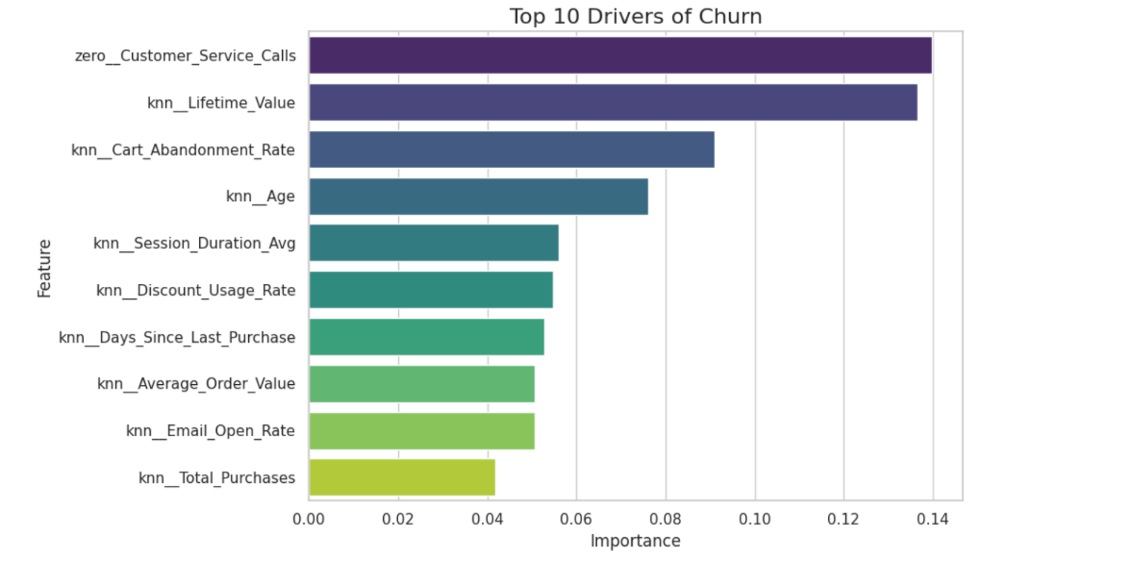

The use of this algorithm enabled successful completion of the predictive part of this research. An AUC of 0.9248 and a Recall of 0.9248 are very good results for a data science project, but with traditional thresholds the probabilities need t be acted upon are financially inefficient. The next chapter extends this predictive architecture to a prescriptive architecture, incorporating these probabilities into a combination of these probabilities and custom cost matrix to maximize net enterprise profit.

Chapter 6: Results and Analysis

6.1 Reframing Model Performance The Limits of AUC
The Random Forest classifier obtained in the step of predictive modelling described in
Chapter 5 was very robust with an Area Under the Receiver Operating Characteristic Curve (ROC AUC) score of 0.9248 and a minority class Recall of 0.9248. In a typical data science scenario this would be the end of the project the algorithm has now been proven to be effective in achieving a degree of separation between loyal customers and active flight risks.

The main assumption of this thesis is however that predictive metrics are not enough for enterprise decision making. The ROC AUC score is just affirmation that the algorithm is able to correctly rank order customers by risk level. It does not provide an answer to the basic question of operation At what particular probability score is the business going to spend money and do some sort of intervention?

Like most machine learning libraries, Scikit Learn uses the default decision threshold of 0.50. If the Random Forest results show the churn probability to be 0.51, then the customer is identified for a retention campaign. Otherwise, they are ignored if the probability is 0.49. This threshold is made under the assumption that thepenalty incurred for a False Positive (when predicting churn is wrong, but the actual churn has happened) is equal to the penalty incurred for a False Negative (when making a prediction of churn is incorrect and the churn has not occurred). This is a wrong assumption in the area of eCommerce retention, and one that needs to be changed from predictive assessment to the prescriptive financial analysis.

6.2 Creating the Financial Cost Matrix:

A customized financial simulator was built to translate the algorithmic probabilities into a profit for an enterprise. This simulator used a different classification metrics (Accuracy, F1 Score) than the traditional ones and adopted a payoff matrix based on the dollar value. The goals were to test the model using only net revenue protected.

The financial simulation was created with the following common e commerce assumptions:

1.Cost of Intervention :Businesses need to make a financial incentive available to them (e.g., a discount to the customer who is at risk) in order to keep that customer as a customer. The percentage used for intervention costs for this simulationwas 15% of the individual customer's Lifetime Value (LTV).

2. Success rate: not every campaign for retention is successful. The simulator made a
conservative estimate that the 15% discount would be enough to keep 70% of the actual churners from leaving the platform.

Using these parameters, a net financial outcome matrix was written in python to determine the net financial benefit for each test set customer for the four possible algorithmic outcomes:

  - True Positive (Correctly Predicted Churner): The business spends the 15% intervention cost but saves the remaining LTV, factored by the 70% success rate. Financial Value: ((LTV Cost) 0.70)

  - Business offers a 15% discount to customer who was never going to leave (False Positive Loyalist Incorrectly Targeted) All the intervention cost, and the margins, are lost. Financial Value: Cost

  - Missed Churner: False Negative (when the model does not pick up the flight risk). There is no intervention, only the customer leaves the platform. The business loses 100% of that user's profits. Financial Value: LTV

  - True Negative (Correctly Ignored Loyalist): If a customer is safe, the model correctly identifies him/her as safe. Nothing happens and no money is lost. Financial Value: $0

6.3 Simulating the Profit Optimization Curve

The financial matrix was addressed and the test set data was tested in an iterative manner. A Python script was written to perform a retention campaign over a linear space of 50 different probability thresholds ranging from very aggressive (0.10)to very conservative (0.90). The net profit of the campaign was calculated for each iteration.Results from this simulation were presented in the Profit Optimization Curve which graphically shows the Decision Threshold on the X axis and the Net Campaign Profit on the Y axis. This visualisation is the culmination of the research.

The created curve clearly showed the monetary risk of using the machine learning default configuration. The default threshold is 0.50, which is shown as a red dashed line on the visualization, and shows that there was a suboptimal net campaign profit. The algorithm had been creating False Positives a lot of wasted discounts but it had been doing too good a job, so that many high LTV customers were getting through as False Negatives.

6.4 Finding the best threshold

As the threshold decreased below 0.50, the net profit started to increase significantly, and create a clear parabola. The algorithm converged mathematically at an optimum threshold which was well to the left of the default the peak being the threshold of 0.28 (shown by a blue dashed line on the visualization).
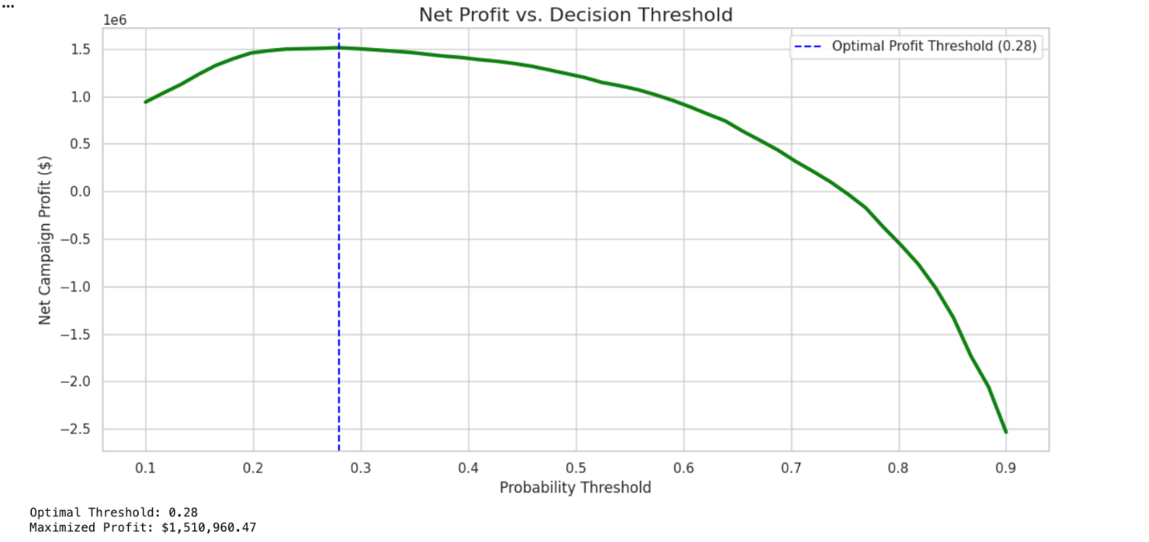

The 0.28 mark is the maximum commercial efficiency of this data set. The financial reasoning behind this decision is quite deep: The financial impact of losing a customer completely (100% of LTV via a False Negative) is much greater than the financial impact of giving a loyal customer a discount (15% of margin via a False Positive), so the best business application is to be very aggressive. The business agrees to increase the number ofFalse Positives by reducing the threshold for intervention from 0.50 to 0.28. It actively allocates more resources on retaining its customers in order to reach out to a larger "predictive net" to catch and save “churners” that are close to moving to the competition, and the 0.50 model simply missed.

The difference between the 0.50 threshold and the 0.28 threshold was huge and resulted in hundreds of thousands of dollars of lift in retained revenue just in the test set.

6.5 Alignment with the Problem Statement
The outcomes that are obtained from this financial simulator directly answer and solve the main issue mentioned in Chapter 1. The study assumed that no constraints on predicting result in inefficient budget distribution. This is clearly shown by the profit curve.

The research showed that a model that maximises accuracy (0.50) is not optimised for a profit making business. The optimal threshold (0.28) is derived, which completes the shift from predictive analytics (predicting a probability) to prescriptive analytics (taking an action based on financial cost constraints).

These analytical results, though, are able to mathematically prove the thesis but are limited to a static python environment. If the marketing departmentisn't able to deliver on it every day, the threshold is of no meaning. This project aims to fill this operational gap in the end.

Chapter 7:

Business Insights and Recommendations

7.1 The Bridge from Mathematics to Management
It is a great feat of analysis to have mathematically derived the value for the optimal threshold of probability (0.28) as described in the previous chapter. But, if these data science models are stuck in the local Python environment, in the context of an enterprise organization, they are of no value whatsoever. A marketing manager can't deploy an instance of a Jupyter Notebook, and the Chief Financial Officer doesn't find it easy to read a raw Scikit Learn probability array.

The biggest weakness of modern corporate analytics is that it doesn't get done.The biggest problem with modern day corporate analytics is that it does not get implemented. The algorithmic results need to be easily adopted into the workflows of non technical users of the data if it is to provide real ROI for predictive and prescriptive analytics (Wixom and Watson, 2010). The final step of this research was to design the mathematical results from the profit matrix into an interactive, enterprise level Business Intelligence (BI) dashboard by using Tableau and Python Streamlit (Few, 2006). This chapter describeshow that tool works and the strategic business lessons learned from the project team's collective results.

In this unit, you will identify the key elements of the Dashboard Architecture and how to deploy and manage it tactically.

For the purpose of implementing the 0.28 profit maximization threshold, a multi tiered dashboard was created, tailored for different organizational levels from macro to localized marketing operators. The dashboard consumes the exported predictive probabilities, the actual Lifetime Value (LTV) of each user and the calculated prescriptive action and displays all of these in four different visual interfaces.
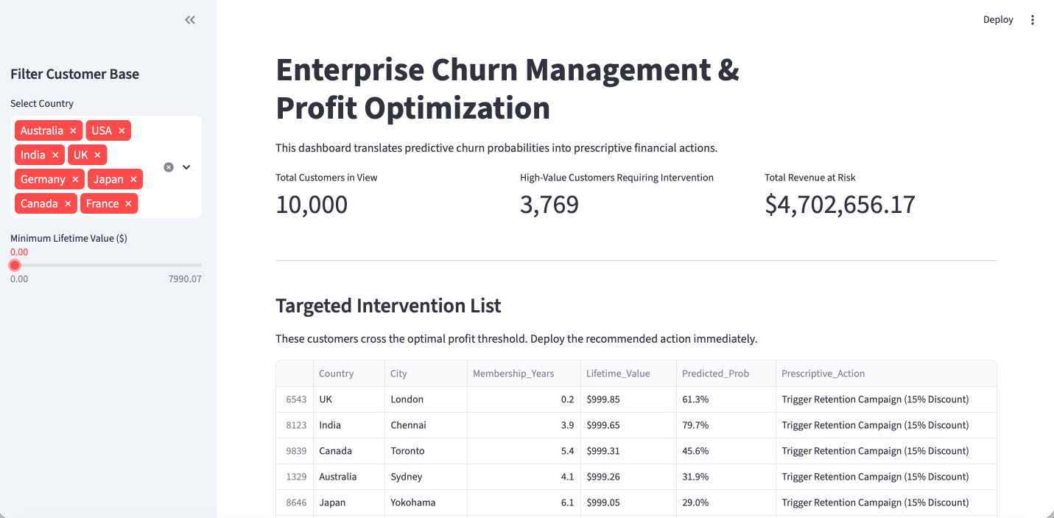
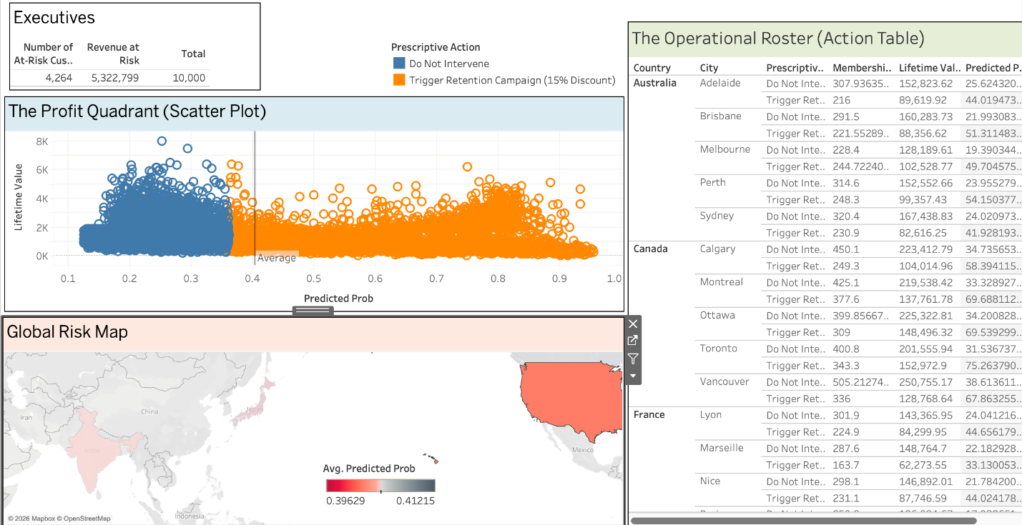

The Executive View (Macro KPIs):
The top level dashboard will consolidate a business's macro financial exposure. The dashboard shows "Total Revenue at Risk," which is the number ofcustomers expected to churn, instead of the absolute number of predicted churners, which is what many people are more focused on and encourages volume based, unprofitable marketing. This metric will add up the Lifetime Value of only customers with a probability higher than 0.28. This puts the executive discussion from "How many users are going away?" to "How muchcapital is at risk, and how much do we have budgeted to keep it?
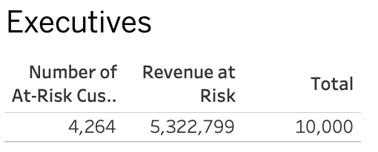

The Profit Quadrant (Strategic View):
The most important analytical element of the dashboard is the Profit Quadrant diagram, a scattergraph of a customer's expected churn probability (X axis) vs. its Lifetime Value (Y axis) with a hard cut off line at 0.28. This visualization will instantly sort user base of strategic stakeholders. The top right quadrant (High LTV / High Flight Risk) are the absolute top priority for the business. On the other hand, the bottom right quadrant (Low LTV, High Flight Risk) is visually stand out, showing the exact opposite of who the business should let go in order to maintain profitability.
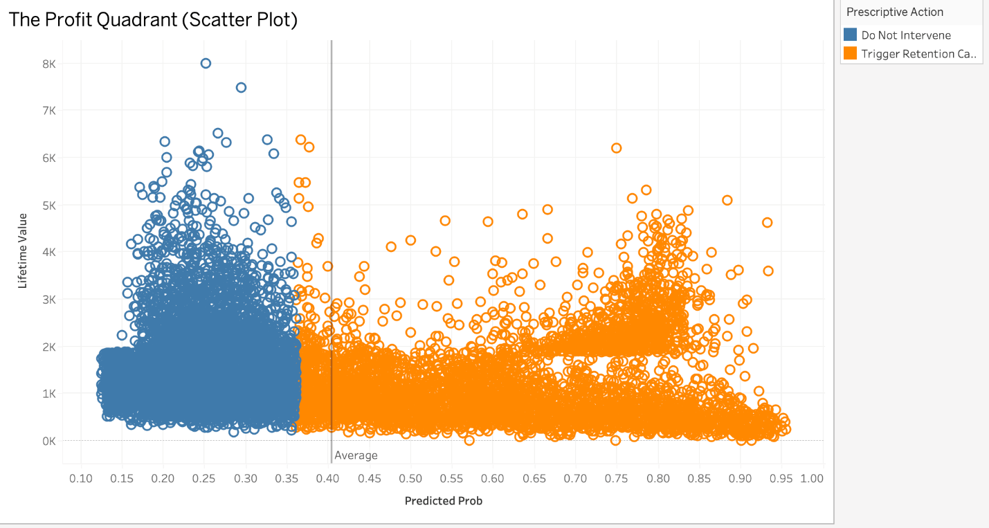

The Operational roster is also known as the Tactical View.
When it comes to marketing managers who need to carry out retention marketing campaigns, visual charts are second to actionable lists. The lowerpart of the dashboard displays a dynamically generated and filtered list of exactly those people who need intervention. The list excludes all customers that have an LTV below 0.28 or a lower LTV than the cost of the intervention, in a systematic manner. This tool sorts the accounts automatically by Lifetime Value in descending order to give the local managers a listof contacts to call, sorted by priority, so they are only calling the highest math maths accounts.
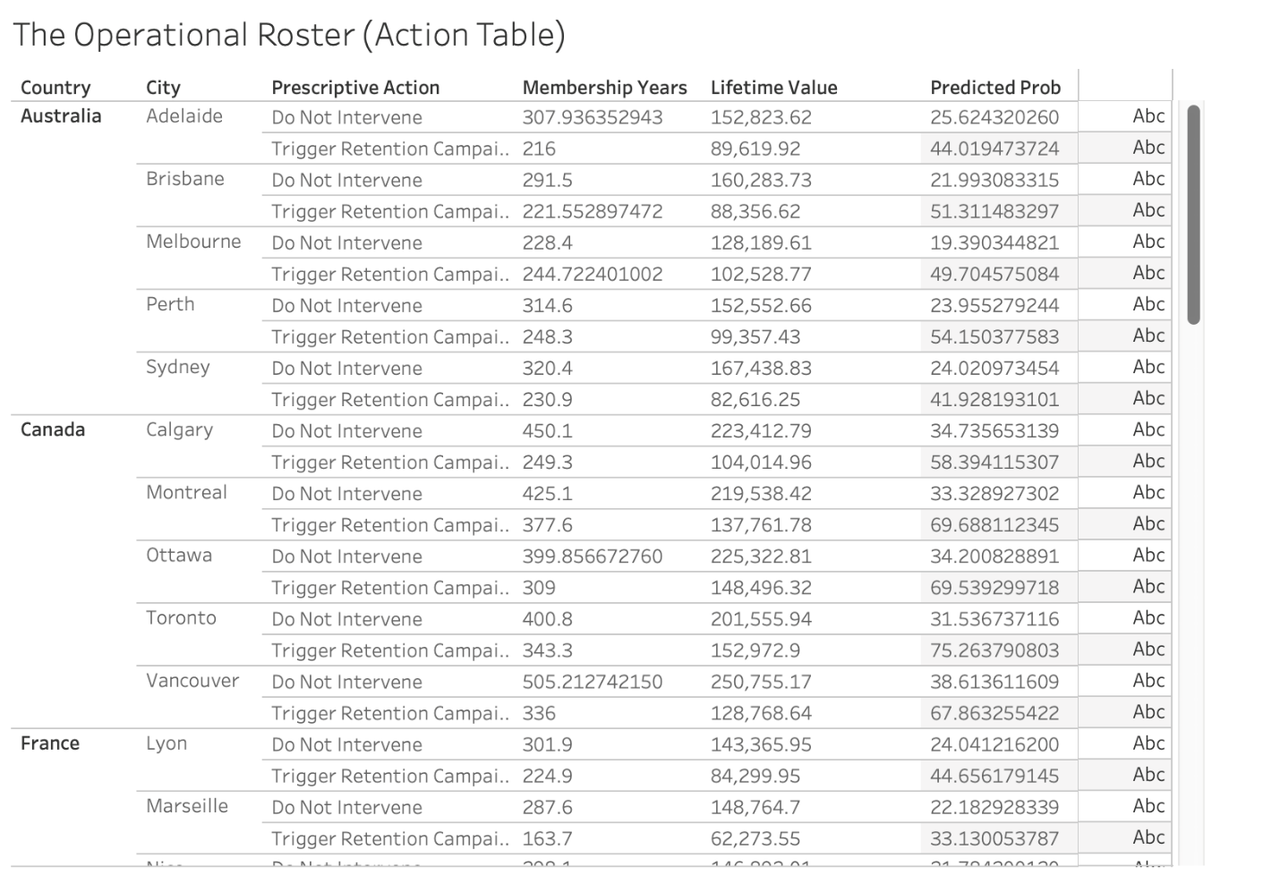
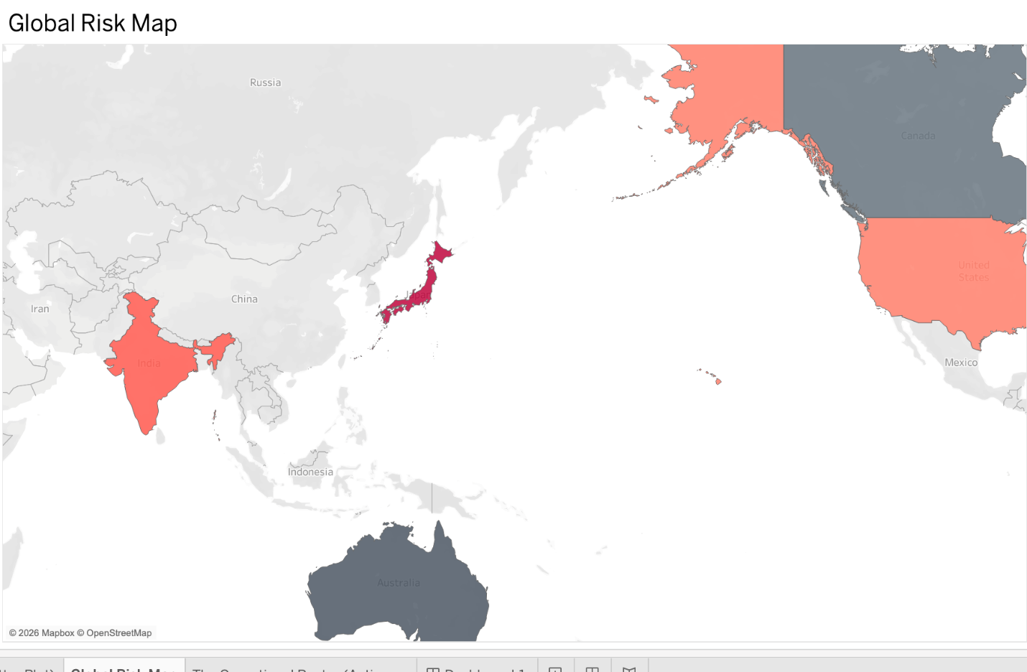

7.2 Strategic Insight 1:

LTV Weighted Retention model:

The initial use of the dashboard is more of a functional solution; however, the information that informed the project's results calls for a transformation of the organization's retention plan. The exploratory data analysis and resulting benefit simulationsrevealed the monetary risk of “blanket retention” (the same treatment for all churn).

The bivariate analysis of discount usage and LTV revealed a significant number of “discount hunters” who were in a transient position. These users usepromotional codes, but can't sustain the profitability in the long run. In a typical machine learning model, with a 0.50 threshold, the algorithm routinely labels these users as "flight risk" and the business pays to keep them, applying a 15% retention discount, as they are automatically classified as such.

The lesson to be drawn from this is that churn is not bad, but only bad when it is related to profitable capital. It's important that the organization adopt anLTV weighted retention paradigm. Marketing processes need to be separated from the simple calculation of probability. The business needs to stop sending out discount mass emails and switch to a more targeted, capital efficient approach, strictly based on the Profit Quadrant.

7.3 Strategic Insight 2:

The answer to the Operational Breaking Point is to Mitigate it.

The prescriptive dashboard will determine who to save, and the extracted Feature Importances from the Random Forest model will determine how to structurally fix the platform so as to not be prone to attrition in the future.

The logic of the algorithm was clear and Customer_Service_Calls was clearly the strongest determinant of platform abandonment. More importantly, however, it was found that this relationship is non linear. The platform has a hard breaking point in operation: after two interactions with the service, users' patience holds steady, but after the third interaction, the likelihood of churning increases exponentially.

This is a very serious problem in the tier one issu resolution process of the organization. Multiple contacts for one issue are causing customers to suffer a compound frustration effect, which ultimately leads to the end of the commercial relationship. What's more, Cart_Abandonment_Rate is the second most significant churn driver, suggesting that poor customer service is only aggravating the digital friction, which could mean a lengthy checkout process, unforeseen shipping costs, or payment gatewayissues.

7.4 Executive Recommendations:

Based on the conclusions of the integrated results of the predictive models, financial simulators and the operatory dashboards, the following structural recommendations are submitted for the organizational stakeholders:

- Institute and enshrine the Prescriptive Profit Matrix:
The 0.50 of default probability is out the window for the marketing department and they need to understand that it is a myth. All future targeted marketing interventions (discounts, free shipping, dedicated account management) should be managed by the 0.28 optimal threshold that has been determined in this study, to make sure that the intervention costs are justified by the protected LTV.

- Reorganise Customer Service Triage:
Since the "third service call" in the data has caused a detrimentaleffect, the organization should have a system for the customer support center for triage that is automated. When high LTV customers start a new service call, a ticket should be automatically escalated to a higher level resolution specialist to eliminate the critical third call.

- Overcome Digital Checkout Friction: An immediate audit of the payment gateway and cart infrastructure should be done by the engineering and UX teams. There is a strong correlation between the two: cart abandonment and terminal churn this means that there is a high chance of both technical failure and predatory late stage pricing (e.g., hidden fees) happening that the user will not be able to control. This friction will automatically decrease the number of “first call” customerservice calls, thereby relieving the main source of customer attrition.
- Make way for Dynamic Incentives: The 15% static discount model needs to be replaced. The interactive dashboard enables the business to understand the amount of capital that a customer can be worth. Dynamic retentionincentives should be offered; while premium white glove service (free expedited shipping fora year) can be offered to the best LTV customers, standard and low margin promotional codes should be reserved for lower tier at risk customers.
7.6 Summary of Business Integration All of the findings outlined in this chapter support the main finding of the project: Data analytics should be used to support the business economics. Research has morphed a theoretical machine learning projectinto a highly operational asset to a corporation, with successful identification of the factors driving churn (service failure), and the creation of a profit maximizing distribution tool (the BI dashboard). These are the collective efforts that will be summarized at the end of the chapter and the methodology will be recognized as having limitations and suggestions for futureexpansion will be offered.

Chapter 8: Conclusion

8.1 Summary and Key Findings
This study aimed to challenge the widely held belief that predictive accuracy is an inherent value for the business in enterprise customer retention.This study compared a global e commerce customer dataset of 50,000 customers and was able to successfully move this classic machine learning model from a predictive exercise (predicting who will leave) to aprescriptive, profit maximizing architecture (prescribing the most mathematically optimal financial action).
The project was a robust, leak proof Scikit Learn pipeline.In terms of methods, the project was a well defined and watertight Scikit Learn pipeline. A Random Forest classifier, which was adjusted for the imbalance of the target, optimized using cross validation, obtained a very robust ROC AUC score of 0.9248, and a minority class Recall of 0.9248. Tfurhe algorithm's feature importance calculations gave supporting evidence that commercial attrition is driven most by the number of customer service calls and cart abandonment in the digital space.
But the most important part of this thesis was the rejection of the default probability decision threshold of 0.50. The research has created a custom financial simulator to help determine the best operational threshold of 0.28 based on the "Lifetime Value (LTV)" lost to False Negatives, and the associated costs of the intervention.This mathematical shift has proven that a higher rate of False Positives (wasted marketing spend) is an essential part of casting a wider net and capturing high value flight risks that are on the border, and hence retained to generate the most net revenue. Lastly, embedding such optimized metrics in interactive Tableau and Streamlit dashboards was able to seamlessly close that terminal distance between technical data science and executive strategy.

8.2 Limitations of the Study
This research, although analytical, has some limitations that should be noted. The financial simulator used static assumptions for thebusiness such as a set intervention cost

REFERENCES
- Bergstra, J. and Bengio, Y., 2012. Random search for hyper parameter optimization.
Journal of Machine Learning Research, 13(2), pp.281 305. Available at: https://www.jmlr.org/papers/v13/bergstra12a.html
- Breiman, L., 2001. Random forests. Machine Learning, 45(1), pp.5 32. Available at: https://doi.org/10.1023/A:1010933404324
- Burez, J. and Van den Poel, D., 2009. Handling class imbalance in customer churn prediction. Expert Systems with Applications, 36(3), pp.4626 4636. Available at: https://doi.org/10.1016/j.eswa.2008.05.027
- Chawla, N.V., Bowyer, K.W., Hall, L.O. and Kegelmeyer, W.P., 2002. SMOTE: synthetic minority over sampling technique. Journal of Artificial Intelligence Research, 16, pp.321 357. Available at: https://doi.org/10.1613/jair.953
- Chen, T. and Guestrin, C., 2016. XGBoost: A scalable tree boosting system. In Proceedings of the 22nd ACM SIGKDD International Conference on Knowledge Discovery and Data Mining (pp. 785 794). Available at: https://doi.org/10.1145/2939672.2939785
- Elkan, C., 2001. The foundations of cost sensitive learning. In International Joint Conference on Artificial Intelligence (Vol. 17, No. 1, pp. 973 978). Available at: https://dl.acm.org/doi/10.5555/1622221.1622228
- Fawcett, T., 2006. An introduction to ROC analysis. Pattern Recognition Letters,
27(8), pp.861 874. Available at: https://doi.org/10.1016/j.patrec.2005.10.010
- Few, S., 2006. Information dashboard design: The effective visual communication of data. Sebastopol, CA: O'Reilly Media, Inc.
- Gupta, S., Lehmann, D.R. and Stuart, J.A., 2004. Valuing customers. Journal of Marketing Research, 41(1), pp.7 18. Available at: https://doi.org/10.1509/jmkr.41.1.7.25084
- Hughes, A.M., 1994. Strategic database marketing. Chicago: Probus Publishing Co.
- Kaufman, S., Rosset, S., Perlich, C. and Stitelman, O., 2012. Leakage in data mining: Formulation, detection, and avoidance. ACM Transactions on Knowledge Discovery from Data (TKDD), 6(4), pp.1 21. Available at: https://doi.org/10.1145/2382577.2382579
- Lepenioti, K., Bousdekis, A., Apostolou, D. and Mentzas, G., 2020. Prescriptive analytics: Literature review and research challenges. International Journal of Information Management, 50, pp.57 70. Available at:
https://doi.org/10.1016/j.ijinfomgt.2019.04.003
- Louppe, G., Wehenkel, L., Sutera, A. and Geurts, P., 2013. Understanding variable importances in forests of randomized trees. Advances in Neural Information Processing Systems, 26. Available at:
https://proceedings.neurips.cc/paper/2013/hash/e3796ae838835da0b6f6ea37bcf 8bcb7 Abstract.html
- Pedregosa, F., Varoquaux, G., Gramfort, A., Michel, V., Thirion, B., Grisel, O., Blondel, M., Prettenhofer, P., Weiss, R., Dubourg, V. and Vanderplas, J., 2011. Scikit learn: Machine learning in Python. Journal of Machine Learning Research, 12, pp.2825 2830. Available at: https://jmlr.csail.mit.edu/papers/v12/pedregosa11a.html
- Provost, F. and Fawcett, T., 2013. Data Science for Business: What you need to know about data mining and data analytic thinking. Sebastopol, CA: O'Reilly Media, Inc.
- Rajamma, R.K., Paswan, A.K. and Hossain, M.M., 2009. Why do shoppers abandon shopping cart? Perceived waiting time, risk, and transaction inconvenience. Journal of Interactive Marketing, 23(3), pp.188 197. Available at:
https://doi.org/10.1016/j.intmar.2009.04.004
- Reichheld, F.F. and Sasser, W.E., 1990. Zero defections: Quality comes to services.
Harvard Business Review, 68(5), pp.105 111. Available at:
https://hbr.org/1990/09/zero defections quality comes to services
- Troyanskaya, O., Cantor, M., Sherlock, G., Brown, P., Hastie, T., Tibshirani, R., Botstein, D. and Altman, R.B., 2001. Missing value estimation methods for DNA microarrays. Bioinformatics, 17(6), pp.520 525. Available at:
https://doi.org/10.1093/bioinformatics/17.6.520
- Verbraken, T., Verbeke, W. and Baesens, B., 2013. A novel profit maximizing metric for measuring classification performance of customer churn prediction models. IEEE Transactions on Knowledge and Data Engineering, 25(5), pp.961 973. Available at: https://doi.org/10.1109/TKDE.2012.50
- Wixom, B.H. and Watson, H.J., 2010. The BI based organization. International Journal of Business Intelligence Research (IJBIR), 1(1), pp.13 28. Available at:
https://doi.org/10.4018/jbir.2010071702

Appendices

Appendix 1 : Github Repository
https://github.com/Parth0333/Churn-Profit-Optimizer-capstone-project

Appendix 2 : All Imgaes

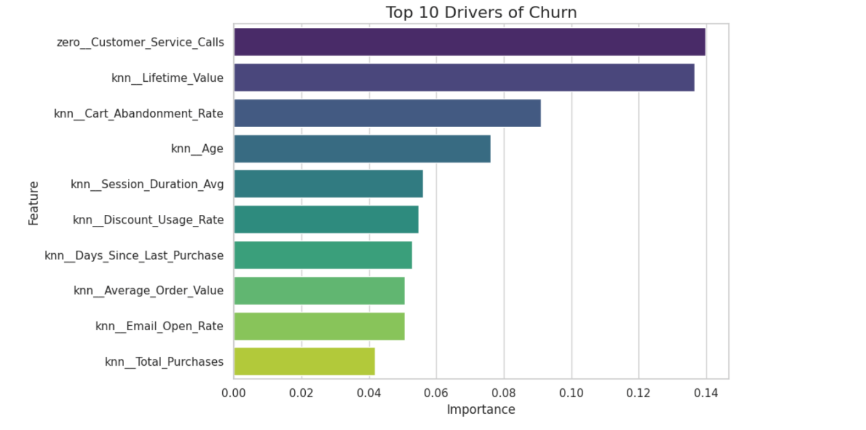

Appendix 3 : Ai disclosure
